Ball Tracking with OpenCV
by Siddharth Verma on September 14, 2015
The goal here is fair self-explanatory:
- Step #1: Detect the presence of a colored ball using computer vision techniques.
- Step #2: Track the ball as it moves around in the video frames, drawing its previous positions as it moves.
The end product should look similar to the GIF and video above.
After reading this blog post, you’ll have a good idea on how to track balls (and other objects) in video streams using Python and OpenCV.
Looking for the source code to this post?
Jump right to the downloads section.

Ball tracking with OpenCV
Let’s get this example started. Open up a new file, name it ball_tracking.py , and we’ll get coding:
Ball Tracking with OpenCV
Python

1  2  3  4  5  6  7  8  9  10  11  12  13  14  15  16 | # import the necessary packages  from collections import deque  from imutils.video import VideoStream  import numpy as np  import argparse  import cv2  import imutils  import time  # construct the argument parse and parse the arguments  ap = argparse.ArgumentParser()  ap.add_argument("-v", "--video",  help="path to the (optional) video file")  ap.add_argument("-b", "--buffer", type=int, default=64,  help="max buffer size")  args = vars(ap.parse_args())
Lines 2-8 handle importing our necessary packages. We’ll be using deque , a list-like data structure with super fast appends and pops to maintain a list of the past N (x, y)-locations of the ball in our video stream. Maintaining such a queue allows us to draw the “contrail” of the ball as its being tracked.
We’ll also be using imutils , my collection of OpenCV convenience functions to make a few basic tasks (like resizing) much easier. If you don’t already have imutils installed on your system, you can grab the source from GitHub or just use pip to install it:
Ball Tracking with OpenCV
Shell

1 | $ pip install --upgrade imutils
From there, Lines 11-16 handle parsing our command line arguments. The first switch, --video is the (optional) path to our example video file. If this switch is supplied, then OpenCV will grab a pointer to the video file and read frames from it. Otherwise, if this switch is not supplied, then OpenCV will try to access our webcam.
If this your first time running this script, I suggest using the --video switch to start: this will demonstrate the functionality of the Python script to you, then you can modify the script, video file, and webcam access to your liking.
A second optional argument, --buffer is the maximum size of our deque , which maintains a list of the previous (x, y)-coordinates of the ball we are tracking. This deque allows us to draw the “contrail” of the ball, detailing its past locations. A smaller queue will lead to a shorter tail whereas a larger queue will create a longer tail (since more points are being tracked):
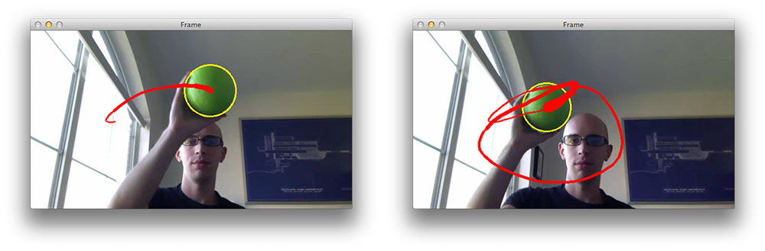
Figure 1: An example of a short contrail (buffer=32) on the left, and a longer contrail (buffer=128) on the right. Notice that as the size of the buffer increases, so does the length of the contrail.
Now that our command line arguments are parsed, let’s look at some more code:
Ball Tracking with OpenCV
Python

18  19  20  21  22  23  24  25  26  27  28  29  30  31  32  33  34  35 | # define the lower and upper boundaries of the "green"  # ball in the HSV color space, then initialize the  # list of tracked points  greenLower = (29, 86, 6)  greenUpper = (64, 255, 255)  pts = deque(maxlen=args["buffer"])  # if a video path was not supplied, grab the reference  # to the webcam  if not args.get("video", False):  vs = VideoStream(src=0).start()  # otherwise, grab a reference to the video file  else:  vs = cv2.VideoCapture(args["video"])  # allow the camera or video file to warm up  time.sleep(2.0)
Lines 21 and 22 define the lower and upper boundaries of the color green in the HSV color space (which I determined using the range-detector script in the imutils library). These color boundaries will allow us to detect the green ball in our video file. Line 23 then initializes our deque of pts using the supplied maximum buffer size (which defaults to 64 ).
From there, we need to grab access to our vs pointer. If a --video switch was not supplied, then we grab reference to our webcam (Lines 27 and 28) — we use theimutils.video VideoStream threaded class for efficiency. Otherwise, if a video file path was supplied, then we open it for reading and grab a reference pointer on Lines 31 and 32 (using the built in cv2.VideoCapture ).
Ball Tracking with OpenCV
Python

37  38  39  40  41  42  43  44  45  46  47  48  49  50  51  52  53  54  55  56  57  58  59  60  61 | # keep looping  while True:  # grab the current frame  frame = vs.read()  # handle the frame from VideoCapture or VideoStream  frame = frame[1] if args.get("video", False) else frame  # if we are viewing a video and we did not grab a frame,  # then we have reached the end of the video  if frame is None:  break  # resize the frame, blur it, and convert it to the HSV  # color space  frame = imutils.resize(frame, width=600)  blurred = cv2.GaussianBlur(frame, (11, 11), 0)  hsv = cv2.cvtColor(blurred, cv2.COLOR_BGR2HSV)  # construct a mask for the color "green", then perform  # a series of dilations and erosions to remove any small  # blobs left in the mask  mask = cv2.inRange(hsv, greenLower, greenUpper)  mask = cv2.erode(mask, None, iterations=2)  mask = cv2.dilate(mask, None, iterations=2)
Line 38 starts a loop that will continue until (1) we press the q key, indicating that we want to terminate the script or (2) our video file reaches its end and runs out of frames.
Line 40 makes a call to the read method of our camera pointer which returns a 2-tuple. The first entry in the tuple, grabbed is a boolean indicating whether the frame was successfully read or not. The frame is the video frame itself. Line 43 handles VideoStream vs VideoCapture implementations.
In the case we are reading from a video file and the frame is not successfully read, then we know we are at the end of the video and can break from the while loop (Lines 47 and 48).
Lines 52-54 preprocess our frame a bit. First, we resize the frame to have a width of 600px. Downsizing the frame allows us to process the frame faster, leading to an increase in FPS (since we have less image data to process). We’ll then blur the frame to reduce high frequency noise and allow us to focus on the structural objects inside the frame , such as the ball. Finally, we’ll convert the frame to the HSV color space.
Lines 59 handles the actual localization of the green ball in the frame by making a call tocv2.inRange . We first supply the lower HSV color boundaries for the color green, followed by the upper HSV boundaries. The output of cv2.inRange is a binary mask , like this one:
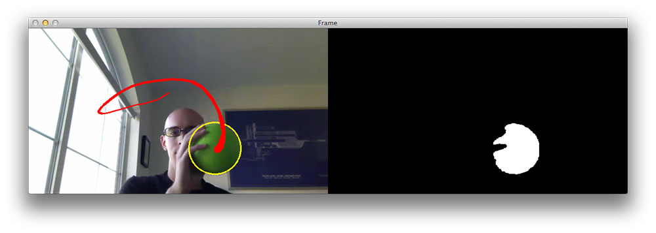
Figure 2: Generating a mask for the green ball using the cv2.inRange function.
As we can see, we have successfully detected the green ball in the image. A series of erosions and dilations (Lines 60 and 61) remove any small blobs that may be left on the mask.
Alright, time to perform compute the contour (i.e. outline) of the green ball and draw it on ourframe :
Ball Tracking with OpenCV
Python

63  64  65  66  67  68  69  70  71  72  73  74  75  76  77  78  79  80  81  82  83  84  85  86  87  88  89 | # find contours in the mask and initialize the current  # (x, y) center of the ball  cnts = cv2.findContours(mask.copy(), cv2.RETR_EXTERNAL,  cv2.CHAIN_APPROX_SIMPLE)  cnts = imutils.grab_contours(cnts)  center = None  # only proceed if at least one contour was found  if len(cnts) > 0:  # find the largest contour in the mask, then use  # it to compute the minimum enclosing circle and  # centroid  c = max(cnts, key=cv2.contourArea)  ((x, y), radius) = cv2.minEnclosingCircle(c)  M = cv2.moments(c)  center = (int(M["m10"] / M["m00"]), int(M["m01"] / M["m00"]))  # only proceed if the radius meets a minimum size  if radius > 10:  # draw the circle and centroid on the frame,  # then update the list of tracked points  cv2.circle(frame, (int(x), int(y)), int(radius),  (0, 255, 255), 2)  cv2.circle(frame, center, 5, (0, 0, 255), -1)  # update the points queue  pts.appendleft(center)
We start by computing the contours of the object(s) in the image on Line 65 and 66. On the subsequent line, make the function compatible with all versions of OpenCV. You can read more about why this change to cv2.findContours is necessary in this blog post. We’ll also initialize the center (x, y)-coordinates of the ball to None on Line 68.
Line 71 makes a check to ensure at least one contour was found in the mask . Provided that at least one contour was found, we find the largest contour in the cnts list on Line 75, compute the minimum enclosing circle of the blob, and then compute the center (x, y)-coordinates (i.e. the “centroids) on Lines 77 and 78.
Line 81 makes a quick check to ensure that the radius of the minimum enclosing circle is sufficiently large. Provided that the radius passes the test, we then draw two circles: one surrounding the ball itself and another to indicate the centroid of the ball.
Finally, Line 89 appends the centroid to the pts list.
The last step is to draw the contrail of the ball, or simply the past N (x, y)-coordinates the ball has been detected at. This is also a straightforward process:
Ball Tracking with OpenCV
Python

91  92  93  94  95  96  97  98  99  100  101  102  103  104  105  106  107  108  109  110  111  112  113  114  115  116  117  118  119  120 | # loop over the set of tracked points  for i in range(1, len(pts)):  # if either of the tracked points are None, ignore  # them  if pts[i - 1] is None or pts[i] is None:  continue  # otherwise, compute the thickness of the line and  # draw the connecting lines  thickness = int(np.sqrt(args["buffer"] / float(i + 1)) * 2.5)  cv2.line(frame, pts[i - 1], pts[i], (0, 0, 255), thickness)  # show the frame to our screen  cv2.imshow("Frame", frame)  key = cv2.waitKey(1) & 0xFF  # if the 'q' key is pressed, stop the loop  if key == ord("q"):  break  # if we are not using a video file, stop the camera video stream  if not args.get("video", False):  vs.stop()  # otherwise, release the camera  else:  vs.release()  # close all windows  cv2.destroyAllWindows()
We start looping over each of the pts on Line 92. If either the current point or the previous point is None (indicating that the ball was not successfully detected in that given frame), then we ignore the current index continue looping over the pts (Lines 95 and 96).
Provided that both points are valid, we compute the thickness of the contrail and then draw it on the frame (Lines 100 and 101).
The remainder of our ball_tracking.py script simply performs some basic housekeeping by displaying the frame to our screen, detecting any key presses, and then releasing the vs pointer.

Ball tracking in action
Now that our script has been coded it up, let’s give it a try. Open up a terminal and execute the following command:
Ball Tracking with OpenCV
Shell

1 | $ python ball_tracking.py --video ball_tracking_example.mp4
This command will kick off our script using the supplied ball_tracking_example.mp4 demo video. Below you can find a few animated GIFs of the successful ball detection and tracking using OpenCV:
Figure 3: An example of successfully performing ball tracking with OpenCV.
Figure 3: An example of successfully performing ball tracking with OpenCV.
For the full demo, please see the video below:
Finally, if you want to execute the script using your webcam rather than the supplied video file, simply omit the --video switch:
Ball Tracking with OpenCV
Shell

1 | $ python ball_tracking.py
However, to see any results, you will need a green object with the same HSV color range was the one I used in this demo.

Summary
In this blog post we learned how to perform ball tracking with OpenCV. The Python script we developed was able to (1) detect the presence of the colored ball, followed by (2) track and draw the position of the ball as it moved around the screen.
As the results showed, our system was quite robust and able to track the ball even if it was partially occluded from view by my hand.
Our script was also able to operate at an extremely high frame rate (> 32 FPS), indicating that color based tracking methods are very much suitable for real-time detection and tracking.
If you enjoyed this blog post, please consider subscribing to the PyImageSearch Newsletter by entering your email address in the form below — this blog (and the 99 posts preceding it) wouldn’t be possible without readers like yourself.

